
CARBON REDUCTION PLAN GUIDANCE

Notes for Completion
Where an In-Scope Organisation has determined that the measure applies to the procurement, suppliers wishing to bid for that contract are required at the selection stage to submit a Carbon Reduction Plan which details their organisational carbon footprint and confirms their commitment to achieving Net Zero by 2050.
Carbon Reduction Plans are to be completed by the bidding supplier and must meet the reporting requirements set out in supporting guidance, and include the supplier’s current carbon footprint and its commitment to reducing emissions to achieve Net Zero emissions by 2050.
The CRP should be specific to the bidding entity, or, provided certain criteria are met, may cover the bidding entity and its parent organisation. In order to ensure the CRP remains relevant, a Carbon Reduction Plan covering the bidding entity and its parent organisation is only permissible where the detailed requirements of the CRP are met in full, as set out in the Technical Standard and Guidance, and all of the following criteria are met:
- The bidding entity is wholly owned by the parent;
- The commitment to achieving net zero by 2050 for UK operations is set out in the CRP for the parent and is supported and adopted by the bidding entity, demonstrated by the inclusion in the CRP of a statement that this will apply to the bidding entity;
- The environmental measures set out are stated to be able to be applied by the bidding entity when performing the relevant contract; and
- The CRP is published on the bidding entity’s website.

Bidding entities must take steps to ensure they have their own CRP as soon as reasonably practicable and should note that the ability to rely on a parent organisation’s Carbon Reduction Plan may only be a temporary measure under this selection criterion.
The Carbon Reduction Plan should be updated regularly (at least annually) and published and clearly signposted on the supplier’s UK website. It should be approved by a director (or equivalent senior leadership) within the supplier’s organisation to demonstrate a clear commitment to emissions reduction at the highest level. Suppliers may wish to adopt the key objectives of the Carbon Reduction Plan within their strategic plans.
A template for the Carbon Reduction Plan is set out below. Please complete and publish your Carbon Reduction Plan in accordance with the reporting standard published alongside this PPN.

Carbon Reduction Plan Template
Supplier name: ……GenX MedIcare Ltd …………………………………………………………….
Publication date: …………12/01/2025………………....................................................

Commitment to achieving Net Zero

[GenX MediCare Ltd] is committed to achieving Net Zero emissions by 2050.

Baseline Emissions Footprint
Baseline emissions are a record of the greenhouse gases that have been produced in the past and were produced prior to the introduction of any strategies to reduce emissions. Baseline emissions are the reference point against which emissions reduction can be measured.
[Instructions to Suppliers:
Please provide details of your organisation’s baseline emissions below. If your organisation has not previously assessed or reported emissions, please detail this below and use your first reporting period as your Baseline.]
Baseline Year: 2023/24
Additional Details relating to the Baseline Emissions calculations.
Emissions data had not been published in prior years therefore we selected 2021/22 as our base year. The methodology for measuring our carbon footprint is in line with the Greenhouse Gas protocol and the BEIS Environmental Reporting Guidelines. The calculations were completed on the SmartCarbon Calculator using the UK Government emissions factors.
Baseline year emissions:
EMISSIONS | TOTAL (tCO₂e)
Scope 1 | 10.02
Scope 2 | 13.05
Scope 3  (Included Sources) | Our baseline year for scope 3 will be financial year 2023/24 (1st April 2023 – 31st Match 2023). Our scope 3 emissions subsets exceed the requirements of PPN06/21. See Section 3 for scope 3 information.  Waste - 0.10 Business Travel – 87.03
Total Emissions | 110.2

Current Emissions Reporting
Reporting Year: 2024/25
EMISSIONS | TOTAL (tCO₂e) 493
Scope 1 | 10
Scope 2 | 13.01
Scope 3  (Included Sources) | Our baseline year for scope 3 will be financial year 2024/25 (1st April 2024 – 31st Match 2025). Our scope 3 emissions subsets exceed the requirements of PPN06/21. See Section 3 for scope 3 information.  Waste - 0.10 Business Travel – 83.08
Total Emissions | 106.19

Emissions reduction targets

[Instructions to Suppliers:

If existing emissions reduction targets are in place for your organisation, please provide details below.

If you have no previous emissions reduction commitment, or if this is your organisation’s first carbon footprint, please provide targets for your organisation]

In order to continue our progress to achieving Net Zero, we have adopted the following carbon reduction targets.
The carbon reduction opportunities in this plan, once fully implemented, will reduce GenX Medicare’s' GHG emissions each year in line to achieve net zero emissions by 2050.

The areas for concentrated reduction strategies are as follows:

4.1 Business travel
Evaluate and, where possible, adopt means of reducing business travel, including continued use of video conferencing, to achieve sustainable long-term reduction of emissions that will be reported annually.

We project that carbon emissions will decrease over the next five years to 100 tCO₂e by 2050. This is a reduction of 3%

Progress against these targets can be seen in the graph below:

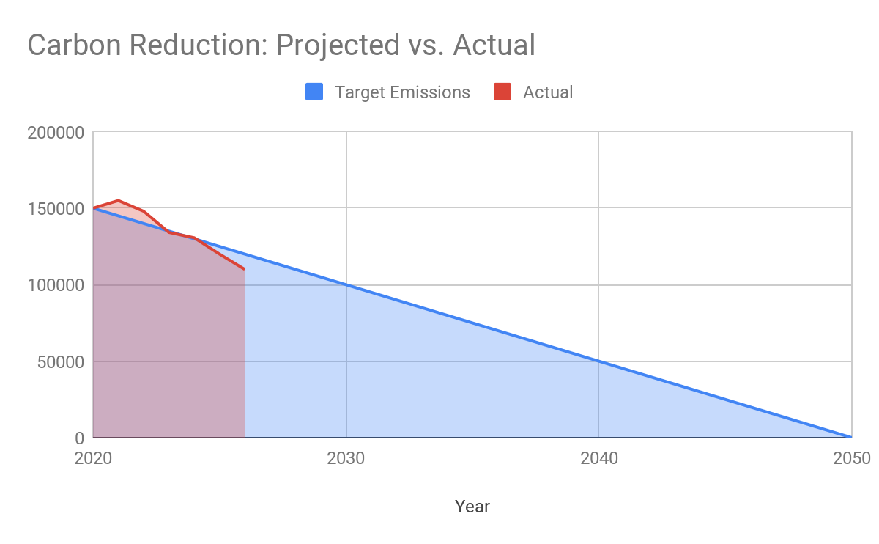

Carbon Reduction Projects

Completed Carbon Reduction Initiatives
The following environmental management measures and projects have been completed or implemented since the 2021/22 baseline. The carbon emission reduction achieved by these schemes equate to 5 tCO₂e, a 3%ge reduction against the 2021/22 baseline and the measures will be in effect when performing the contract
[Instructions to Suppliers:
Briefly provide details of some of your completed carbon reduction projects. This is for information only.
Electric vehicles introduced & solar panels installed
This may include environmental management measures such as certification schemes like ISO14001 or PAS 2060, signing up to SBTI or specific measures you have taken such as; the adoption of LED/PIR lighting controls, changes to policy resulting in a reduction in company travel and flights or the electrification of the company fleet.]
In the future we hope to implement further measures such as:

[Instructions to Suppliers:
Briefly provide details of some of any likely/proposed future carbon reduction projects. This is for information only.]
Reduction in packaging

Declaration and Sign Off
This Carbon Reduction Plan has been completed in accordance with PPN 06/21 and associated guidance and reporting standard for Carbon Reduction Plans.
Emissions have been reported and recorded in accordance with the published reporting standard for Carbon Reduction Plans and the GHG Reporting Protocol corporate standard and uses the appropriate Government emission conversion factors for greenhouse gas company reporting.
Scope 1 and Scope 2 emissions have been reported in accordance with SECR requirements, and the required subset of Scope 3 emissions have been reported in accordance with the published reporting standard for Carbon Reduction Plans and the Corporate Value Chain (Scope 3) Standard.
This Carbon Reduction Plan has been reviewed and signed off by the board of directors (or equivalent management body).

Signed on behalf of the Supplier:

…… …………………………………………………………….
Date: ……12/01/2025………………….……….

Bidding supplier or ‘bidding entity’ means the organisation with whom the contracting authority will enter into a contract if it is successful.
Technical Standard can be found at: https://assets.publishing.service.gov.uk/government/uploads/system/uploads/attachment_data/file/991625/PPN_0621_Technical_standard_for_the_Completion_of_Carbon_Reduction_Plans__2_.pdf
Guidance can be found at: https://assets.publishing.service.gov.uk/government/uploads/system/uploads/attachment_data/file/991623/Guidance_on_adopting_and_applying_PPN_06_21___Selection_Criteria___3_.pdf
https://ghgprotocol.org/corporate-standard
https://www.gov.uk/government/collections/government-conversion-factors-for-company-reporting
https://ghgprotocol.org/standards/scope-3-standard

